Dear Parent

Thank you for taking an interest in our Little Learners, our pre-reception sessions for pupils who turn 4 on or after 1st September.

Please register your interest below so we can keep you up to date with our transition sessions and term dates.

NB Trannack School data protection policy can be found on our website www.trannack.croftymat.org

Child’s full name |  |  |  |  |  | Date of birth
Address
Phone contact
Email contact
Emergency contact details if different from above
Please tick the boxes below to indicate the days you may require.
If your hours exceed 15 hours and you do not have ‘30 hour funding’ the excess can be paid for at £4.75 per hour. Hours can be shared by 2 settings.
Monday 9:00 – 12:00 (3hrs) |  | Tues 9:00 – 15:00 (6hrs) |  |  |  |  | Weds 9:00 15:00 (6hrs)
Please also indicate below which additional days you would want to use if we were able to offer them:
Thursday 9:00 – 15:00 (6hrs) |  |  |  | Friday 9:00 15:00 (6hrs)
Anticipated Start Date
Parent Signature |  |  |  |  | Date

Many thanks,
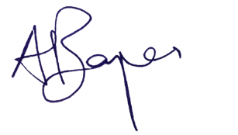

Mr Adam Boyes
Head of School

