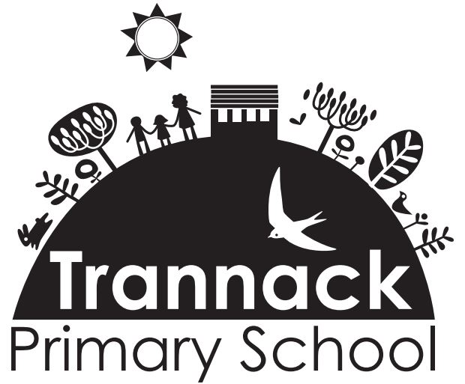
‘If you are going to get anywhere in life you have to read a lot of books.’
Roald Dahl

‘To learn to read is to light a fire; every syllable that is spelled out is a spark.’
Victor Hugo

‘There are many little ways to enlarge your child’s world. Love of books is the best of all.’
Jacqueline Kennedy

INTENT:
At Trannack School we want our children to adore reading. We are committed to every child learning to read as quickly as possible from the moment they enter school. Learning to read opens the world around them and has an impact on their future life choices and chances. When the basics are embedded and mastered, subsequent learning becomes easier. At Trannack, we have high expectations of ourselves and seek for all children to make rapid progress, so they become fluent and confident readers by the age of 6 and able to access the world around them.

IMPLEMENTATION:
Early Reading
Children in EYFS, Year 1 and Year 2 who are still on the programme take part in high quality daily phonics sessions using the RWI strategy. All children participate by listening and responding, by practising and applying the core fundamental skills to build their word recognition, and to read with growing speed and accuracy to become confident and skilled readers. We strive for children to crack the phonic code as soon as possible so they change from learning to read to reading to learn. Children practise their reading with decodable books that run alongside the programme. The pace and the consistency of the programme is a key element to developing reading skills at a level where the children can confidently access the reading materials and learn new skills.

During the children’s RWI journey, the children will learn all the 44 speed sounds and corresponding letter groups and then match the corresponding graphemes as they progress through EYFS and KS1. By learning to recognise and read letter sounds, they will be taught the skill of oral blending which is a vital skill for the initial stage of early reading. As they become confident with the initial sounds and blending simple words, they will be introduced to digraph and trigraph sounds. As the children become more confident in segmenting and blending words, they will be taught how to blend silently using ‘Fred in their head’. Children will also be exposed to ‘alien words’ (nonsense words) throughout to ensure they are reading by blending. Children are assessed half termly to ensure they are at a level where they will be successful and confident in their reading ability. The leader for early reading has regular release time to monitor and coach staff.

Assessment is ongoing and therefore groups are fluid with a formal assessment half termly to ensure they are taught at a level where they will be successful and confident in their reading ability. This consistent, rigorous and daily approach to phonics provides our children with the foundations to become enthused readers with a passion for storytelling, literature and vocabulary.
All pupils need to understand the alphabetic code if they are to become accurate readers and spellers. Some children with SEND may require additional ‘top up’ to secure and embed learning. Children will learn to read and spell words that do not conform with alphabetic patterns (common exception words) to ensure they can decode both fiction and non-fiction texts through discussion, performance and teacher led activities.

From Year 2, once the children can confidently and fluently decode and have completed the RWI programme, they will further develop their reading comprehension by using the RWI comprehension programme. When ready, they will move onto chapter books and follow the VIPERS approach to reading with expert modelled prosody (stress and intonation in language).

Viper’s lessons from Year 2
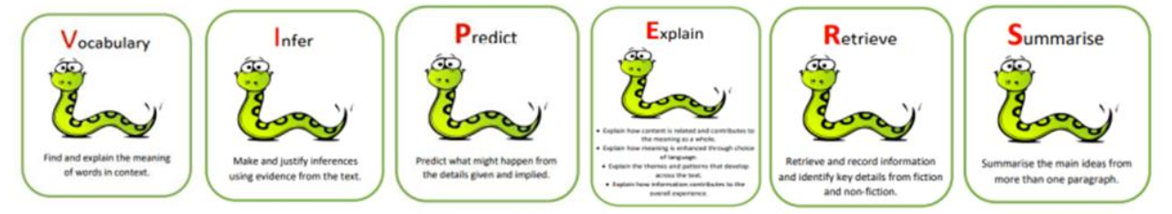
Children are explicitly taught the skills of reading (outlined in the National Curriculum) using the VIPERS approach. VIPERS stands for:
As the children in Year 2 are introduced to the VIPERS approach, they are taught how to echo and choral read. This is further supported during whole class Literacy lessons. Questions linking to the VIPERS are scaffolded to ensure children are using the VIPERS approach correctly. The VIPERS are linked to the KS1 content domain:
KS1 Content Domain Reference | VIPER
1a draw on knowledge of vocabulary to understand texts | Vocabulary
1b identify/ explain key aspects of fiction and non-fiction, such as characters, events, titles and information. | Retrieve
1c identify and explain the sequences of events in texts | Sequence
1d make inferences from the text | Infer
1e predict what might happen on the basis of what has been read so far | Predict

In KS1, questions are mainly based around the retrieval approach in order for the children to learn the key skill of finding relevant information in their text as ‘Explain’ doesn’t feature in the content domains. Vocabulary, prediction and summarising are also practised to ensure the children are familiar with the concepts once they reach KS2. In Key Stage 2, all lessons follow a methodical approach where the content domain of the VIPERS will be shared with the children and elements of VIPERS are discussed:
KS2 Content Domain Reference | VIPER
2a Give/explain the meaning of words in context | Vocabulary
2b retrieve and record information/ identify key details from fiction and non/fiction | Retrieve
2c summarise main ideas from more than one paragraph | Summarise
2d make inferences from the text/ explain and justify inferences with evidence from the text | Infer
2e predict what might happen from details stated or implied | Predict
2f identify/explain how information/ narrative content is related and contributes to meaning as a whole | Explain
2g identify/explain how meaning is enhanced through choice of words and phrases | Explain
2h make comparisons within a text | Explain

During whole class guided reading, children have access to high quality texts which link to the focus text in Literacy lessons and the overarching topic being taught in class, where possible (although the quality of the text is more important than the link to the topic). The text will often be the same in reading and writing lessons. Children explore tier 2 (green words) vocabulary daily, so they are secure in the definitions of these words, and they are understood and embedded when they are encountered in the text and over the wider school day. Wow word walls are also in classrooms so tier 2 words can be displayed and referred to frequently. Tier 3 words, those that are specific to subject discipline are also displayed on red paper on subject specific displays.

Children read in the VIPER sessions in a variety of ways. They will hear the teacher model fluent reading with prosody, repeat by echoing the teacher and will also participate in choral reading. The teacher, when necessary, will chunk a sentence and put it back together. By repeating the sentence, children acquire automaticity and practise the rhythm of reading to aid comprehension. This will be a daily reading experience. Essential vocabulary will be shared at the point of reading so that children understand the content of the text. Vocabulary is then later explored as part of the VIPERS lesson. Teachers will ask a variety of quick fire warm up questions involving who, what, where, when, who and why.

VIPERS whole class reading sessions take place 4-5 times per week. During the reading lesson, the children are then asked VIPERS questions which link to the extract of text they’ve read. The questions planned for the children will link to the KS1 or KS2 domain. To support this, children are given sentence stems and vocabulary which they are expected to use. They are encouraged to provide evidence for their answer based on the extract of text they have read.

During these sessions, children will be exposed to both fiction texts (usually the whole class text) and non-fiction from ‘The Literacy Shed Comprehension’ Units. These units are chosen to support the fiction text and learning in other curriculum areas.

Example of Guided Reading Texts for each term UKS2

Recording and Assessment during VIPERS sessions
At Trannack, we actively encourage children to orally talk through their answers to ensure it is their best thinking before writing anything down. They can discuss this with their peers or with an adult in class, but if they are working individually, they are encouraged to edit their answer accordingly to make it the best answer it can be. Whole class discussions take place where children share their thoughts and ideas.

During reading sessions, staff will live mark - this means they will be able to listen to individuals as they read. This gives the class teacher an opportunity to assess a child’s reading ability and understanding of the text. Children are expected to edit their own learning.

Accelerated Reader
Accelerated Reader is introduced at Trannack when the children can demonstrate that they are becoming more fluent and confident in their reading ability. This can be as early as from Year 2 when the children have completed the RWI programme. Books on the AR scheme are matched to the child’s reading ability so they text is ‘just right’ for them to enjoy.

AR is research-proven, pupil driven and teacher-guided. The children are ‘in charge’ while the teacher guides the child in ensuring the text chosen is accessible and completely at the right level for them. Children participate in engaging quizzes and activities that help support and hone reading skills – encouraging further growth and development.
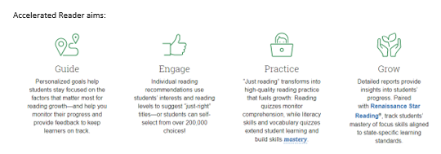

During Accelerated Reader time at Trannack, 15 minutes per day, teachers focus on specific children by listening to them read individually. Children are also given time to share texts in pairs or read individually. Time is also given for children to complete the Accelerated Reader quizzes from the books that they have chosen to read in the library system. These quizzes, along with other regular assessments ensures the books being read are matched to their reading ability. Parents can also follow their child’s progress through the Accelerated Reader app. At Trannack, we are committed to providing new titles by working with the English Hub and OURFP for the latest reading recommendations.

Reading for Pleasure
Here at Trannack, teachers actively promote a love of reading with energy and enthusiasm. They have a focused whole class ‘reading for enjoyment’ session timetabled into every school day, where the teacher reads to the children. They model prosody when reading class novels, focus texts and literature linking to other curriculum areas. Our vibrant classrooms, school library and book-based English curriculum provide many opportunities to promote reading in school. Texts chosen for English lessons are high quality and link explicitly to the topic being covered in class so there is relevance for the children. We ensure that every child has the same access to reading and promote a love of reading for all. We know that if we are passionate about reading, this enthusiasm will captivate, motivate and have a positive impact on the children. We actively encourage teachers and other children to recommend texts they have enjoyed, and these are displayed on the newsletter. We encourage our children to visit the local library and take part in the Summer Reading Challenge. We know that if we are passionate about reading for pleasure, then this will have a positive impact on our children’s future life chances.
Sometimes children need additional support to make expected progress. The following strategies are used to support this further development:
- RWI ‘Pinny Time’ and ‘fast track’ tutoring in EYFS and KS1
- RWI ‘Fresh Start’ in KS2 when needed.
- ‘Nessy’ online learning programme.
- Precision Teaching
- Accelerated Reader
- Star Reading Assessments to target improvement in teaching.
- Parent workshops to support the teaching of reading and RWI in EYFS and KS1
- Priority/ targeted readers – we aim to hear approximately 3x weekly as a minimum.

IMPACT:

Children at Trannack will:
- Read fluently and confidently, with prosody; varying pace, volume and emphasis depending on the demands of the text
- Enjoy reading for pleasure, and do so independently
- Have a wide-ranging vocabulary and keen retrieval skills
- Speak insightfully about and draw astute inferences from the texts that they read, including predicting what might happen next in non-fiction
- Know about a broad range of texts, including fiction, non-fiction and poetry
- Confidently discuss their opinions about what they read

‘I don’t think there’s a big secret about what to do; we need to show children how much we love stories. Read great stories, poems and non-fiction every day, all through school. What we love today they might read tomorrow.’
Ruth Miskin
‘Today a reader, tomorrow a leader.’
Margaret Fuller

